1. 0603 seems to be the best size for SMD prototyping.
2. EPAD pin on regulators (TO-263 package) should be connected to ground?
3. The minimal recommended capacitor is 47uF, however the selected capacitor has a (+ -20%) tolerance. Which means it might have a value lower than 47uF. Is that something I should be worried about?
4. The 1.85V regulator is untested on the breadboard I shall record every design detail.

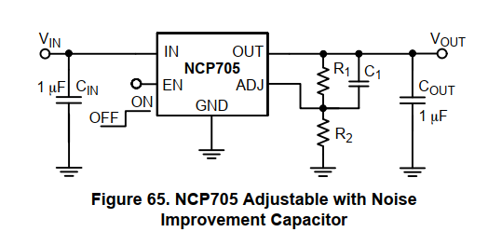

1. To achieve 1.85V a R2 = 99.048kOhm resistor is needed (while R1 = 130k), however only 98.8kOhm resistor is available on the market. This would result in a 1.8526V output voltage. I wonder if that 0.0026 surplus will be an issue?
2. Data sheet’s note on Cin: It is recommended to connect a minimum of 1uF Ceramic X5R or X7R capacitor close to the IN pin of the device.
3. Data sheet’s note on Cout: The NCP705 requires an output capacitor connected as close as possible to the output pin of the regulator. The minimal capacitor value is 1uF and X7R or X5R dielectric due to its low capacitance variations over the specified temperature range.
4. Data sheet’s note on C1: To improve dynamic performance capacitor C1 should be at least 1 nF. Recommended range of capacity is between 10 nF and 100 nF. Higher value of capacitor C1 increasing start-up time.
5. X5R or X7R are class 2 dielectric capacitors:

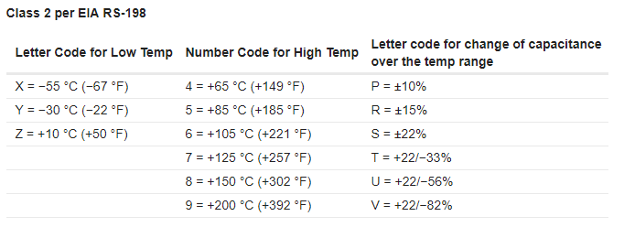

Details see the following link:

<https://forum.digikey.com/t/understanding-ceramic-capacitor-temp-coefficients/727>

1. I can’t find the datasheet of the socket I used I have to assume that all pins have a 0.5mm diameter, it should be standardized, but I need to find a way to double check later.
2. The Arduino due has got only one SPI port, which means one side of the IC reading can not be read by Arduino. However, I propose leaving a test pin for that output so that w can directly see its wave form from a logic analyzer.